
MARMARA UNIVERSITY
FACULTY OF ENGINEERING



Plant Disease Detection Model
Efe Erim
Doğa Şener
Berke Öz

PROGRESS REPORT FOR IE4197
Department of Industrial Engineering

Supervisor
Assoc. Prof. Dr. Ercan Öztemel

ISTANBUL, 2025

- PROJECT STATEMENT
This project aims to develop a deep learning model capable of real-time plant disease detection on mobile devices, with a compact size, low latency, and the ability to incorporate new disease classes without requiring full retraining. Although current deep neural networks achieve high accuracy in plant disease recognition, they typically involve large model sizes (10–200 MB), require powerful GPUs, and suffer from the “catastrophic forgetting” problem—making them impractical for field conditions where internet connectivity is limited and farmers must make quick decisions. Thus, the core motivation of this project is to design a field-ready, efficient, extensible mobile diagnosis system suitable for real-world agricultural environments.

Scope of the Project
The study consists of three main iterations:
- Iteration 1: Training a YOLOv8n based initial model for tomato diseases (9 classes).
- Iteration 2: Adding 1 new plant and diseases class without causing forgetting of previous knowledge.
- Iteration 3: Expanding the model with 4 additional plants.
Across all iterations, the targets include maintaining a model size ≤ 6 MB, achieving ≤ 22 ms inference latency, and preserving high accuracy.

Aim of the Study
The primary aim is to develop a lightweight, extendable, low-latency plant disease detection model that runs on mobile CPUs. Measurable goals include achieving ≥ 90% mAP@50 in the first iteration, maintaining ≥ 85% accuracy on previous classes when new ones are added, and meeting real-time performance requirements on mobile devices.

Motivation
The motivation arises from the increasing need for digital agricultural tools and the lack of accessible, deployable AI systems for farmers, especially in regions with limited computational resources. Existing models are too large and costly to run on mobile devices. This project aligns with national strategies emphasizing artificial intelligence, agricultural technologies, and mobile innovation.

Method

1. Data Collection and Preprocessing
- Public datasets such as PlantVillage and PlantDoc will be combined.
- Over 15,000 labeled images will be split into 80/10/10 training/validation/test sets.

2. Model Development
- YOLOv8n will serve as the base architecture due to its compact size.
- Low-Rank Adaptation (LoRA) layers will be integrated to reduce trainable parameters.
- The model will undergo INT8 post-training quantization and be exported in TFLite format.

3. Incremental Learning Strategy
- In each iteration, previously trained LoRA layers will be frozen to preserve prior knowledge.
- Forgetting will be measured using ΔmAP, with a target of ≤ 5-point degradation.

4. Mobile Deployment and Testing
- The quantized model will be evaluated on a reference mobile device to measure inference latency and performance.
Challenging and Interesting Aspects of the Study
- Maintaining a small model size is highly challenging for deep learning systems.
- Addressing catastrophic forgetting remains a significant research problem.
- Achieving both high accuracy and real-time mobile performance simultaneously is technically demanding.
- Dataset diversity (lighting, angles, device differences) will test the model’s generalization ability.

Expected Outcomes and Impact
- A ≤ 6 MB, ≤ 22 ms mobile-ready plant disease detection model.
- A LoRA-based, incremental-learning architecture scalable without full retraining.
- Open-source release of model files, training notes, and inference code.
- Practical AI tools for agricultural consultants and farmers, enabling real-time field diagnosis.
- Scientific outputs such as conference papers or journal articles.
- CURRENT STATUS

1. Problem Definition: Limitations and Restrictions
The project addresses the fundamental "Scalability-Sustainability Paradox" in deploying mobile agricultural AI. While high-accuracy models exist for single crops (e.g., the Tomato Domain), scaling them to a universal, multi-crop platform without incurring prohibitive costs or failure remains the central challenge.

Technical and Safety Restrictions
The primary technical driver for our research is the failure of conventional fine-tuning methods. When attempting to integrate new crop knowledge (e.g., Apricot diseases) into a deployed model, two major constraints emerge:
- Catastrophic Forgetting: Sequential fine-tuning of the entire model backbone destroys previously learned knowledge (e.g., forgetting all Tomato diseases).
- The Localization Conundrum: As proven in recent literature, a simple parameter-efficient method (like naive LoRA merging) fails for object detection. The simple merging of weights introduces interference that compromises the sensitive bounding box regression head, leading to accurate classification but inaccurate localization (a high-risk safety issue for the farmer). Our work is constrained by the necessity to guarantee high mAP@[.5:.95] (precise localization) across all crops.

Economical and Environmental Constraints
Our solution must be viable for large-scale, low-cost deployment:
- High Retraining Costs: Re-training the entire YOLOv8 backbone for every new crop is economically and computationally unsustainable for a platform aiming to serve many crops (N>5). This is a direct financial barrier to scaling.
- Mobile Constraints: The final deployed model must adhere to size and speed limits for mobile devices, forcing us to use the highly optimized YOLOv8n-INT8 architecture. This quantized, lightweight nature severely exacerbates the technical challenges of weight merging.
- Green AI & Sustainability: The chosen solution, Parameter-Efficient Fine-Tuning (PEFT), is intrinsically sustainable as it minimizes the required computational resources and energy expenditure for every model update.

Social and Ethical Imperative
- The design must support Universal Scalability. Focusing only on major cash crops creates imbalance. Our crop adaptation framework is designed to be a standardized pipeline that allows rapid, equitable adaptation to any regional or niche crop (e.g., Hazelnuts, Grapes), ensuring technology serves all user groups.

2. Root Cause and Effect Analysis
The scalability bottleneck stems from the reliance on monolithic model architectures that are fundamentally incompatible with the sequential nature of real-world data acquisition.
Root Cause (Architectural Rigidity): Standard Deep Learning models are optimized for Joint Training (all data simultaneously), while real-world data arrives Sequentially (one crop domain at a time).
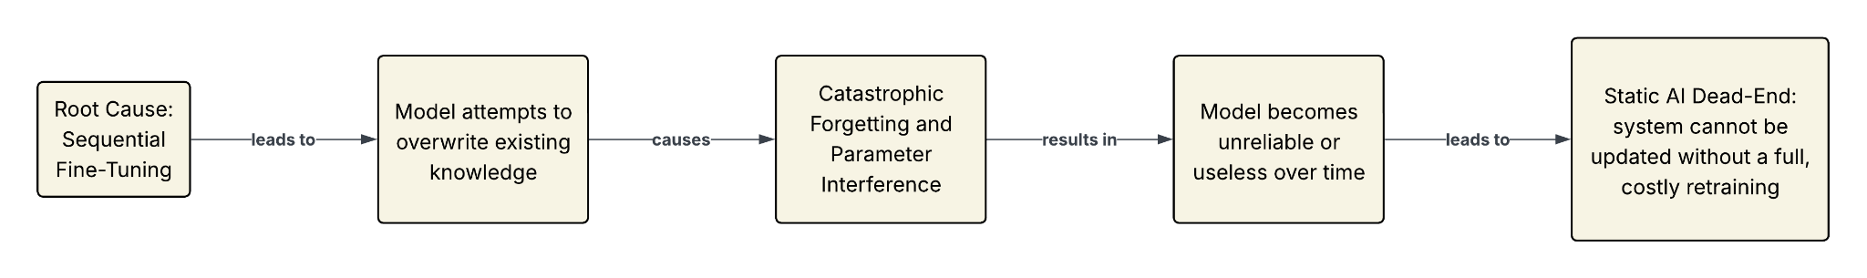
Effect Chain (The Failure):

Our solution, Iterative Merging, is the core component designed to break this cycle by enabling safe, continuous, and efficient modular updates.

3. Studies Completed So Far
- T0: Establishment of the Universal Base Model (Tomato Domain) The objective was to construct a "Universal Feature Extractor" capable of distinguishing laminar (leaf) and volumetric (fruit) geometries. Initial transfer learning attempts failed due to catastrophic forgetting; consequently, a Joint Training strategy was adopted, physically merging Kaggle and Roboflow datasets into 14 distinct classes. A stratified re-balancing protocol was implemented to correct validation distribution discrepancies, ensuring statistical significance.
Quantitative Results of T0: The final "Clean Build" model validates the frozen backbone for Phase T1:
- Accuracy: Achieved 93.5% mAP@50, significantly surpassing the >90% target.
- Localization: Recorded 84.5% mAP@50-95, indicating high-precision bounding box regression.
- Geometric Separation: The Normalized Confusion Matrix confirmed 0.00 cross-domain confusion between leaf and fruit classes.
- Constraints: Retained the YOLOv8n architecture, meeting the ≤22 ms latency requirement (T4 GPU Proxy).
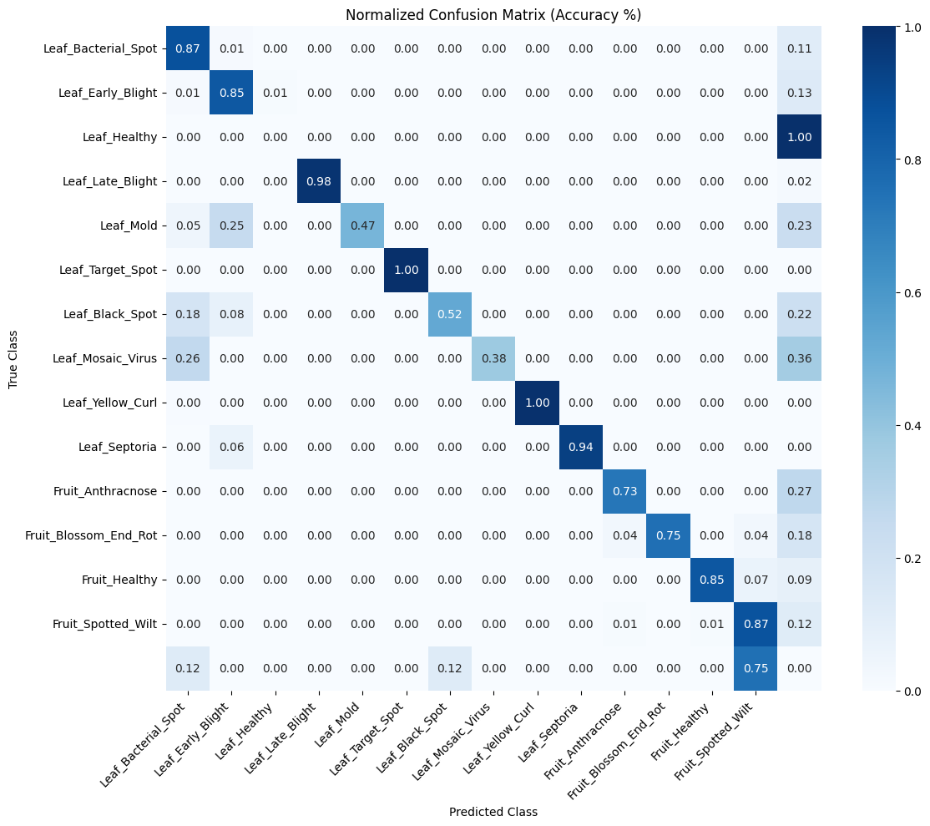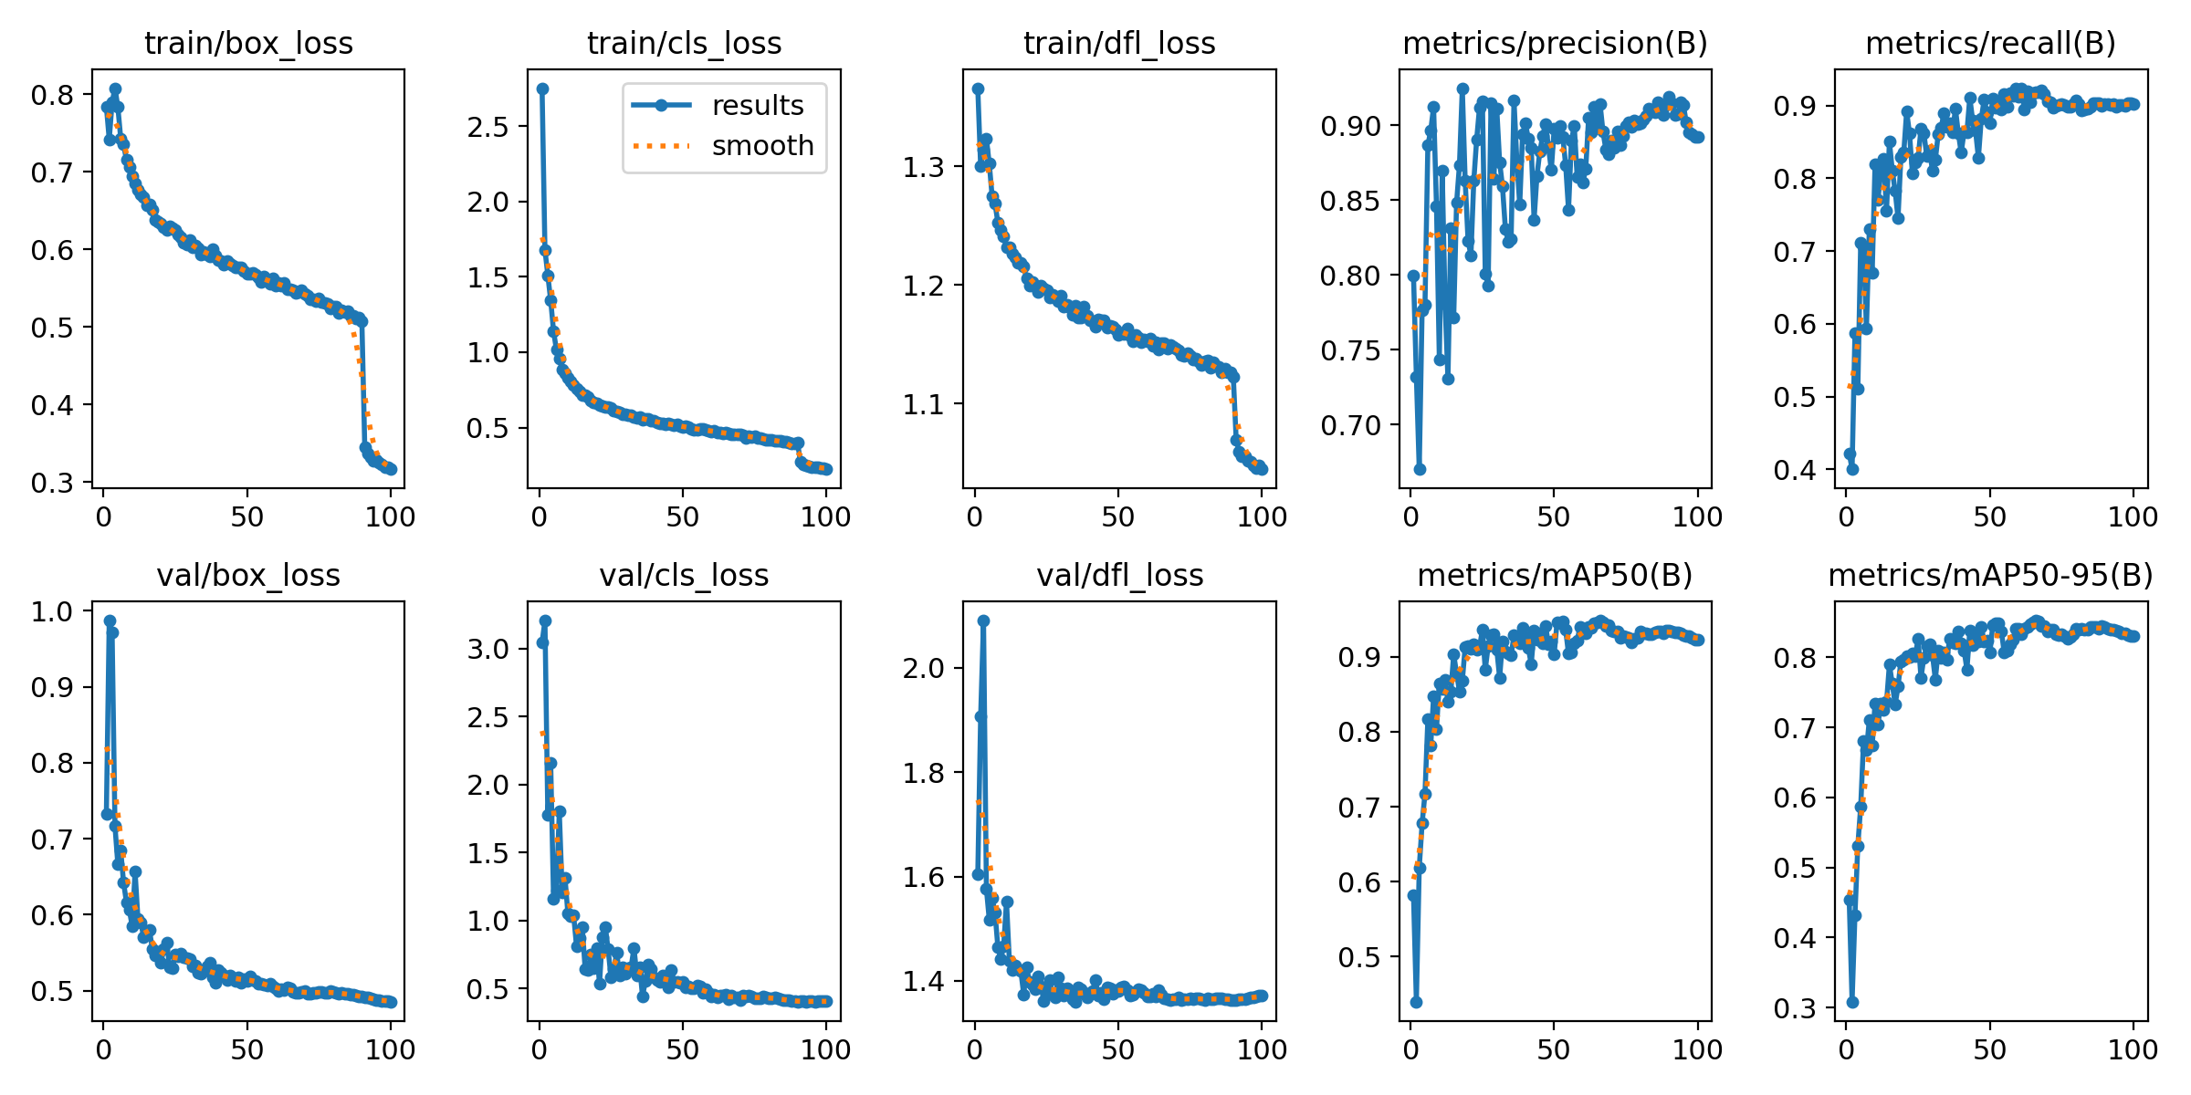

4. Ongoing Studies and Next Steps
ONGOING: Phase T1 (Strawberry Adaptation via Iterative Merging) With the T0 Universal Backbone frozen, the project has transitioned to Phase T1. Key activities include:
- Domain Acquisition: Strawberry disease datasets have been acquired and standardized to YOLO format.
- Adapter Development: Training has commenced for the first Low-Rank Adaptation (LoRA) module for Strawberry pathologies.
- IM Deployment: The team is deploying the IterIS-style optimization algorithm to merge the Strawberry Adapter with the T0 Backbone. This verifies that adding new features does not degrade existing Tomato localization performance.
COMPLETED: Calibration Set Generation The "Alignment Anchor" (Calibration Set) has been generated from the re-balanced T0 dataset. This unlabeled subset now serves as the functional reference for the IM, ensuring mathematical consistency during future domain merges.

- LITERATURE REVIEW
1. Aggarwal, D., Mittal, Y., & Kumar, U. (2024): The Effectiveness of LoRA as PEFT. Studies how well Parameter-Efficient Fine-Tuning (PEFT) methods like Low-Rank Adaptation (LoRA) work on datasets for detecting plant diseases. Demonstrates that LoRA addresses a significant deficiency in computational efficiency and performance, especially in environments with limited resources.

2. Baran, M. F., Kahya, E., & Seydoşoğlu, S. (2025): A look at local YOLO applications. and looks at how the YOLO deep learning architecture has been used in agriculture. It shows that the main YOLO technology used in the project works well with local research focus.

3. Chen, H., Wang, Z., Li, R., Zhu, B., & Chen, L. (2025): IterIS: Merging and Localizing LoRA. Talks about the "Localization Conundrum" that happens when LoRA merging happens and makes it harder for the model to accurately position itself. Proposes the IterIS approach, which uses a layer-wise optimization and iterative inference-solving framework to improve the performance of merged adapters.

4. Coleman, E. N., Quarantiello, L., Hurtado, J., & Lomonaco, V. (2024): Merging Adaptive LoRAs. Shows a new way to do adaptive LoRA merging in Domain-Incremental Learning (DIL) situations. Calculates the inter-task importance coefficient on the fly to get around the problems with fixed-weight merging algorithms.

5. Hu, X., Chen, S., Duan, Q., Ahn, C. K., Shang, H., & Zhang, D. (2025): A review of domain adaptation in the analysis of agricultural images. Provides an extensive examination of Domain Adaptation (DA) and Transfer Learning (TL) methodologies within Big Data contexts for agricultural image analysis. Establishes the necessity of ensuring the model's generalization capability across novel agricultural domains.

6. Jaware, T. H., Badgujar, R. D., & Patil, P. G. (2012): Detecting Diseases Through Image Segmentation. Concentrates on conventional image processing, particularly K-Means-based image segmentation for the identification of plant diseases. Emphasizes the importance of pixel accuracy (segmentation) for precise disease severity assessment.

7. Kahya, E., & Aslan, Y. (2024): Local YOLO Application for Olive Detection. Looks at a real-time olive detection app that uses deep learning and shows how well YOLO-based systems work on Turkish agricultural products.

8. Kahya, E., Yılmaz, A., & Aslan, Y. (2024): YOLOv8 Utilization for Watermelon Disease Identification. This study examines the detection and classification of watermelon leaf diseases utilizing the YOLOv8 architecture. Demonstrates that the project's fundamental architecture (YOLOv8) is effectively tailored to address local agricultural challenges in Turkey.

9. Kang, M., et al. (2023): Knowledge Distillation in Incremental Object Detection. Utilizes the Within-Class and Between-Class Knowledge Distillation mechanism to alleviate catastrophic forgetting in Incremental Object Detection (IOD) tasks. Offers a crucial resolution to a fundamental issue in ongoing learning.

10. Kouw, W. M., & Loog, M. (2018): An Overview of Domain Adaptation and Transfer Learning. It gives the theoretical basis for Transfer Learning (TL) and Domain Adaptation (DA). This framework is essential for ensuring the model's capacity to generalize to novel agricultural domains.

11. Lakshmi, C., et al. (2023): How well YOLO works for finding diseases. Concentrates on how to use YOLO to find plant diseases. Says that YOLO is the best choice, especially for mobile apps, because it has a good balance of fast inference speed and good accuracy.

12. Liu, J., et al. (2023): A framework for efficient continual learning. Presents a framework for efficient continual learning that involves optimizing each layer and transferring knowledge. Underpins the theoretical basis of how PEFT/LoRA methodologies offer an efficiency-oriented resolution to Continual Learning (CL) obstacles.

13. Mohanty, S. P., et al. (2018): Effectiveness of Deep Learning. A groundbreaking study illustrating that the application of Deep Learning (particularly CNNs) for image-based plant disease detection yields a substantial enhancement in accuracy relative to conventional image processing techniques.

14. Morbekar, A., et al. (2020): Initial Application of YOLO in Disease Detection. An initial study investigating the application of YOLO for the identification of plant diseases. Stresses the important balance of speed and accuracy that YOLO provides for mobile devices that need to work in real time.

15. Seif-Ennasr, M., et al. (2025): A Comprehensive Examination of AI Technologies in Agriculture. Offers a methodical analysis of AI-driven technologies in the agricultural sector. It shows that the field is focusing on things like Edge Computing, Object Detection, and Hybrid Systems.

16. Shen, Y., et al. (2025): Optimized YOLOv8 Enhancement. Details the optimization of an improved YOLOv8 model for precision tomato leaf disease detection. Demonstrates how computational complexity can be reduced while maintaining performance using modules like Depthwise Grouped Convolutions.

17. Shmelkov, K., et al. (2017): Fundamentals of KD in Incremental Learning. A foundational work establishing the importance of the Knowledge Distillation (KD) mechanism for Incremental Object Detection (IOD) without catastrophic forgetting.

18. Wang, Y., et al. (2025): YOLOv10 Advancement. Observes the emergence of YOLOv10, the next generation of real-time end-to-end object detection. This model provides an important reference for the project's future scalability goals.

19. Xu, Y., et al. (2023): Quantization-Aware Adaptation, or QA-LoRA. explains the Quantization-Aware Low-Rank Adaptation (QA-LoRA) method. This approach combines the efficiency of LoRA with TFLite INT8 Quantization to address "Green AI" objectives and mobile deployment constraints.

20. Zhao, Y., et al. (2023): Multi-Task Continual Learning. Examines plant disease diagnosis based on multi-task continual learning. Demonstrates the applicability of continual learning protocols to agricultural AI challenges.

21. Zinonos, Z., et al. (2022): A survey of problems with mobile deep learning. Offers a thorough examination of the obstacles and prospective developments in mobile deep learning for the identification of plant diseases. Stresses how important it is to compress models and make them work better for mobile deployment.

The literature indicates a notable shift from traditional image processing methods (Jaware et al., 2012) for plant disease detection to Deep Learning approaches, such as Convolutional Neural Networks (CNNs), resulting in a significant increase in detection accuracy (Mohanty et al., 2018). A systematic literature review by Seif-Ennasr et al. (2025) shows that the use of Artificial Intelligence (AI) in agriculture is heavily focused on Object Detection and the development of Hybrid Systems integrated with Edge Computing (Seif-Ennasr et al., 2025). Within this context, the YOLO (You Only Look Once) architecture stands out as the most suitable option for mobile applications, offering a superior balance between speed and adequate accuracy compared to its competitors (Morbekar et al., 2020; Lakshmi et al., 2023). Nevertheless, simple bounding box detection lacks the pixel precision required to accurately determine the severity of the disease, suggesting that future work should progress toward Image Segmentation (Jaware et al., 2012). The core YOLOv8 architecture, which forms the basis of the project, is a major focal point in current R&D; related studies show that integrating modules like Depthwise Grouped Convolutions optimizes the model, reducing computational complexity without sacrificing inference speed and improving overall accuracy (Shen et al., 2025). Furthermore, the emergence of next-generation models like YOLOv10, which offer a speed advantage through End-to-End detection, is also observed (Wang et al., 2025).
Crucially, none of these works provide a scalable Continual Learning (CL) protocol to address "Catastrophic Forgetting" in Incremental Object Detection (IOD) tasks, which is the project's most significant research challenge (Lakshmi et al., 2023; Zhao et al., 2023). While the Knowledge Distillation (KD) mechanism (Shmelkov et al., 2017; Kang et al., 2023) is vital for mitigating forgetting, and Parameter-Efficient Fine-Tuning (PEFT) / LoRA approaches fill a critical gap in computational and memory efficiency (Liu et al., 2023; Aggarwal et al., 2024), the literature on advanced merging is limited (Coleman et al., 2024).
The project's unique contribution is its Iterative LoRA Merging methodology, which brings together these necessary solutions. When combining small LoRA adapters that were trained for each new crop domain, existing research shows that naive merging methods don't work. This creates a big "Localization Conundrum" because the model can't accurately locate (bounding boxes), even if it correctly identifies the disease (Chen et al., 2025). This issue emerges because, in IOD, knowledge preservation necessitates going beyond classification to precise spatial positioning (Kang et al., 2023). To address these constraints and maintain localization accuracy, the IterIS: Iterative Inference-Solving Alignment for LoRA Merging methodology is introduced, employing a layer-wise optimization and iterative inference-solving framework to enhance the efficacy of merged adapters incrementally (Chen et al., 2025).
Furthermore, guaranteeing the model’s real-world robustness requires addressing the theoretical foundations of Domain Adaptation (DA) and Transfer Learning (TL) (Kouw & Loog, 2018) and acknowledging the critical role of DA techniques in agricultural image analysis (Hu et al., 2025). For the final phase of mobile deployment, model compression techniques are essential (Zinonos et al., 2022). Correspondingly, approaches like QA-LoRA (Quantization-Aware Low-Rank Adaptation), which combine LoRA's efficiency with the target constraint of TFLite INT8 Quantization, address the Green AI objective and mobile deployment limitations (Xu et al., 2023).
Despite the global acceleration in CL and PEFT, the application of such advanced methodologies in Turkish agriculture remains nascent. Current local academic efforts, particularly in object detection, validate the underlying technology of this project: academic work confirms the efficacy of YOLO-based real-time systems for diverse problems like olive detection (Kahya & Aslan, 2024), watermelon leaf disease classification (Kahya et al., 2024), and broader applications of YOLO deep learning in agriculture (Baran et al., 2025). This consistency shows that the project's foundational technology is aligned with local academic focus. However, most local studies remain focused on static models trained on single datasets, confirming the Scalability Gap when compared to the global literature's focus on infinitely scalable CL protocols (Zhao et al., 2023; Chen et al., 2025). The structural heterogeneity of Turkish agriculture, characterized by small, fragmented farms, further magnifies the Domain Adaptation problem (Hu et al., 2025). The project's Iterative LoRA Merging protocol directly addresses this gap by providing the necessary sustainable scalability and robust adaptability required for Turkey's highly diverse agricultural landscape.

- PLANNED PROJECT TASKS

1. Detailed Analysis and Solution Procedure
The project is structured into two main, interconnected phases: Static Optimization (T0) and Dynamic R&D (T1 to T5). The solution hinges on overcoming the Parameter Interference caused by sequential learning in object detection.

1.1. Design Parameters, Targets, and Specifications
Our design parameters are divided into two categories: the Performance Constraints for the mobile deployment and the R&D Objectives to prove the solution's scalability.
A. Design Targets and Constraints

Parameter Type | Specification/Target | Rationale and Measurement
Objective | Maximize Scalability (N-Tasks) | Prove the system can integrate N45 diverse crops sequentially without performance degradation.
Primary Metric (Accuracy) | mAP@[.5:.95] $≥85$ | The critical benchmark. This metric proves precise localization (bounding box accuracy) in addition to classification, directly addressing the "Localization Conundrum" failure mode.
Hard Constraint (Latency) | Latency $≤$ 22ms | Ensures $≥$ 30 FPS (real-time) performance on a mobile device NPU. Measured on the final TFLite/ONNX runtime.
Hard Constraint (Size) | Size $≤$ 6MB | Ensures the final, merged model is small enough for mobile deployment and quick OTA (Over-The-Air) updates. Measured on the final quantized file size.
R&D Constraint | Forgetting $≈$0 | The final models accuracy on the initial Tomato dataset must be statistically equal to base models initial accuracy.

B. The Iterative Merge Specifications
The Iterative Merging is a custom algorithmic solution that replaces the simple, flawed linear merging function.

Iterative Merging Component | Specification | Function
Backbone | YOLOv8n-INT8 | The fixed Universal Feature Extractor. Frozen throughout T1 to T5.
New Knowledge | LoRA Adapter (PEFT) | Small, trainable matrices injected into the frozen backbone to capture domain-specific features for Crop $N$.
Alignment Anchor | Calibration Set (Unlabeled Tomato) | A small, fixed set of unlabeled T0 images used as a reference to run the functional alignment optimization during the merge.
Core Algorithm | IterIS-style Optimization | Non-linear optimization that minimizes the difference between the old model's output features and the new merged model's output features on the Calibration Set. This prevents parameter interference.

2. Data Collection and Management Procedure
The project operates on a sequential, controlled experimentation scheme, where each new crop serves as a new technical challenge for the Iterative Merging.

A. Data Collection and Preparation
- T0 (Base Domain): Consolidate all Tomato datasets. Implement class unification and split into 80/10/10 Train/Validation/Test splits. Create the Calibration Set (a 1-5% subset of unlabeled Tomato images).
- T1 to T4 (New Domains): Prepare datasets for Strawberry, Apricot, Hazelnut, and Grape. All external datasets are converted to the YOLO box format and standardized to the required resolution (e.g., 640x640). Each crop has its own dedicated Test set.
- Final Test Set: The ultimate validation set is the combined test set of all five crops.
B. Experimentation Phases (Sequential Adaptation)
Phase | Crop/Domain | Purpose | Input / Output
T0 | Tomato | Establish the base model (ModelBase​) and validate initial constraints. | Input: TomatoTrain​. Output: Modelv1​
T1 | Strawberry | First test of the IM. Validate the non-linear merge and check for zero forgetting on Tomato. | Input: AdapterStraw​. Output: Modelv2​
T2 | Apricot | Test sequential accumulation. Validate the IM's ability to maintain two prior skills while learning the third. | Input: AdapterApricot​. Output: Modelv3​
T3 & T4 | Hazelnut & Grape | The N=5 Stress Test. Push the system to its limit by integrating the final two geometrically diverse domains. | Input: AdapterHazel​,AdapterGrape​. Output: Modelv5​

PROJECT PLAN

1. Duties of Project Members
Role | Responsibility Focus | Core Deliverables
Efe Erim: Algorithm | Primary focus on R&D: Implementing the IterIS-style merging algorithm and ensuring mathematical stability. | IM Codebase (IterIS/Loss function), Forgetting Analysis, Final Model Merging.
Doğa Şener:Training & Validation | Primary focus on execution: Managing training environments, running the N=5 stress test, and performance verification. | LoRA Training Runs, mAP@[.5:.95] Validation Data, TFLite Constraint Checks.
Berke Öz: Data & Reporting | Primary focus on data standardization, system logging, and final document production. | Calibration Set, Standardized Dataset YAMLs, Final Report (Sections 1, 2, 5, Formatting).

2. Planned Project Tasks and Solution Procedure
Phase | Tasks & Deliverables | Rationale & Measurement
Stage 1: IM Development & Proof of Concept (W1) | Focus: Building and proving the core R&D mechanism (IM). | Critical: Must solve the "Localization Conundrum" before scaling begins.
Stage 2: Sequential Expansion (W2-W3) | Focus: Scaling the system from N=1 to N=3 (Tomato → Strawberry → Apricot). | Test accumulation: Ensure the oldest knowledge (Tomato) is stable after two new tasks are added.
Stage 3: N=5 Stress Test (W4-W5) | Focus: Integrating the final, geometrically complex domains (Hazelnut, Grape). | Test capacity: Push the backbone to its limit and verify the Iterative Merging can handle diverse crop geometries.
Stage 4: Analysis & Reporting (W6-W7) | Focus: Final validation, constraint proof, and documentation. | The final deliverables: Quantitative proof of the Crop Adaptation Framework success and formal thesis submission.

Week | Stage | Task Description | M1 (Algorithm) | M2 (Training/Val) | M3 (Data/Report)
W1 | IM Development & PoC | 1. IM Implementation: Write and debug the IterIS-style merging core code. 2. T1 Execution: Train AdapterStraw​. 3. Calibration: Generate final Calibration Set. | Implement Iterative Merging Core, | Train AdapterStraw​, Prepare environment. | Generate Calibration Set, Write Draft Section 1 (Problem).
W2 | Sequential Expansion (T1/T2) | 1. T1 Validation: Validate Modelv2​ (Tomato/Straw) against mAP@[.5:.95]. 2. T2 Execution (Apricot): Train AdapterApricot​. 3. Merge: Modelv2​+AdapterApricot​→Modelv3​. | Analyze T1 results, Refine IterIS parameters. | Run T1 Validation, Run T2 Training/Execution. | Standardize Apricot Data/YAMLs, Log T1 Validation.
W3 | Sequential Expansion (T3) | 1. T2 Validation: Validate Modelv3​ (Tomato/Straw/Apricot). 2. T3 Execution (Hazelnut): Train AdapterHazel​. 3. Merge: Modelv3​+AdapterHazel​→Modelv4​. | Analyze T2 results, Focus on Forgetting Measure (Tomato check). | Run T2 Validation, Run T3 Training/Execution. | Standardize Hazelnut Data/YAMLs, Log T2 Validation.
W4 | N=5 Stress Test (T4) | 1. T3 Validation: Validate Modelv4​. 2. T4 Execution (Grape): Train AdapterGrape​. 3. Final Merge: Modelv4​+AdapterGrape​→Modelv5​. | Analyze T3 results, Final Iterative Merging Tuning. | Run T3 Validation, Run T4 Training/Final Execution. | Standardize Grape Data/YAMLs, Log T3 Validation.
W5 | Final Validation & Constraint Proof | 1. Final Metrics: Measure Modelv5​'s performance on all 5 domains. 2. Constraint Check: Final TFLite/ONNX conversion, size (≤6MB) and latency (≤22ms) profiling. 3. Baseline Comparison: Run Naive Merge comparison test. | Final Forgetting Analysis (all 5 crops). | Execute Final Validation Suite (mAP across 5 domains), Run Final Constraint Profiling. | Consolidate all 5 validation logs, Write Draft Section 2 & 3 (Methodology).
W6 | Reporting & Analysis | 1. Draft Section 4: Write the quantitative results (charts, tables, discussion of the IM's success). 2. Draft Section 5: Write the Conclusion and Future Work. | Lead drafting Section 4 (Results). | Generate all final charts (Scalability Curve, Pareto Frontier). | Lead drafting Section 5 (Conclusion).
W7 | Final Review & Submission | 1. Final Polish: Review, editing, formatting, and bibliography. 2. Final Handover: Compile full document and models. | Final Code/Technical Review, Submit final draft sections. | Final Data Review, Submit final draft sections. | Compile Final Thesis Document, Ensure all formatting/style is correct, Final Submission.
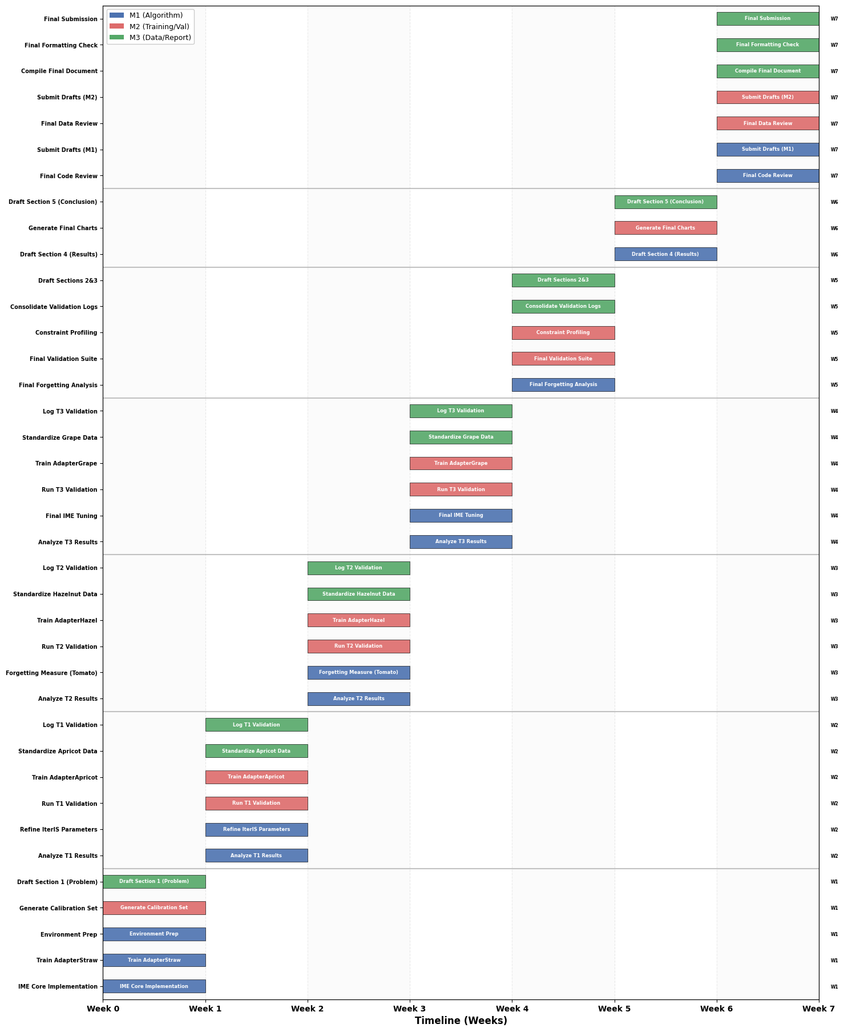

CONCLUSION
The project has achieved a major milestone by finalizing the T0 Universal Base Model. By adopting a Joint Training strategy over conventional transfer learning, we successfully mitigated catastrophic forgetting, yielding a robust baseline with 93.5% mAP. The study empirically demonstrates that a single YOLOv8n architecture can distinguish between 14 distinct disease classes across diverse plant organs with near-zero confusion.
This achievement establishes a stable foundation for the project's core contribution: the Iterative Merging. Current efforts have shifted to Phase T1 (Strawberry), where Low-Rank Adaptation (LoRA) is being applied to validate the system's ability to scale to new crops without full retraining.
Several risks remain. Technically, the Iterative Merging process may not fully preserve localization performance during multi-domain fusion, or quantization constraints may impact mobile accuracy. Variability in data quality across crop domains also poses a generalization risk. Despite these challenges, the findings indicate that the proposed methodology is feasible and holds strong potential for achieving a robust, extensible multi-crop detection system.

REFERENCES
- Aggarwal, D., Mittal, Y., & Kumar, U. (2024). Advancing Image Classification through Parameter-Efficient Fine-Tuning: A Study on LoRA with Plant Disease Detection Datasets. Tiny Papers @ ICLR 2024 Archive.
- Baran, M. F., Kahya, E., & Seydoşoğlu, S. (2025). YOLO Derin Öğrenmenin Tarımsal Uygulama Örnekleri. Liberty Yayınları.
- Chen, H., Wang, Z., Li, R., Zhu, B., & Chen, L. (2025). IterIS: Iterative Inference-Solving Alignment for LoRA Merging. In Proceedings of the IEEE/CVF Conference on Computer Vision and Pattern Recognition (CVPR) (pp. 4829–4838).
- Coleman, E. N., Quarantiello, L., Hurtado, J., & Lomonaco, V. (2024). Adaptive LoRA merging for efficient domain incremental learning. Adaptive Foundation Models: Evolving AI for Personalized and Efficient Learning, NeurIPS 2024 Workshop.
- Hu, X., Chen, S., Duan, Q., Ahn, C. K., Shang, H., & Zhang, D. (2025). Domain Adaptation for Big Data in Agricultural Image Analysis: A Comprehensive Review. arXiv preprint arXiv:2506.05972.
- Jaware, T. H., Badgujar, R. D., & Patil, P. G. (2012). Crop disease detection using image segmentation. World Journal of Science and Technology, 2(4), 190–194.
- Kahya, E., & Aslan, Y. (2024). Derin Öğrenme Destekli Gerçek Zamanlı Zeytin Tespiti Uygulaması. Osmaniye Korkut Ata Üniversitesi Fen Bilimleri Enstitüsü Dergisi, 7(4), 1438–1454.
- Kahya, E., Yılmaz, A., & Aslan, Y. (2024). YOLOv8 ile Karpuz Yaprak Hastalıklarının Tespiti ve Sınıflandırılması. Teknik Bilimler Dergisi, 14(1), 108–117.
- Kang, M., Zhang, J., Zhang, J., Wang, X., Chen, Y., Ma, Z., & Huang, X. (2023). Alleviating catastrophic forgetting of incremental object detection via Within-Class and Between-Class Knowledge Distillation. In Proceedings of the IEEE/CVF International Conference on Computer Vision (ICCV) (pp. 9205–9214).
- Kouw, W. M., & Loog, M. (2018). An introduction to domain adaptation and transfer learning. arXiv preprint arXiv:1812.11806.
- Lakshmi, C., Praavena, B., Sahaana, G., Nithya, J., Gnanasekaran, T., & Hashim, M., (2023). Yolo for Detecting Plant Diseases. In 2023 Third International Conference on Artificial Intelligence and Smart Energy (ICAIS) (pp. 1–6).
- Liu, J., Chen, H., Xu, Y., Wang, J., & Guo, Q. (2023). A layer-wise optimization and knowledge transfer framework for efficient continual learning. Knowledge-Based Systems, 281, 111162.
- Mohanty, S. P., Hughes, D. P., & Salathé, M. (2018). Using deep learning for image-based plant disease detection. Frontiers in plant science, 7, 1419.
- Morbekar, A., Parihar, A., & Jadhav, R. (2020). Crop disease detection using YOLO. In 2020 International Conference for Emerging Technology (INCET) (pp. 1–4).
- Seif-Ennasr, M., Naimi, M., Chikhaoui, M., Bellafkih, M., Benabbes, K., Azough, Z., & Abail, Z. (2025). Harvesting insights on AI-Driven Technologies in Modern Agriculture: A Systematic Literature Review. IEEE Access, 13(2), 143713–143734.
- Shen, Y., Yang, Z., Khan, Z., Liu, H., Chen, W., & Duan, S. (2025). Optimization of improved YOLOv8 for precision tomato leaf disease detection in sustainable agriculture. Sensors, 25(5), 1398.
- Shmelkov, K., Schmid, C., & Alahari, K. (2017). Incremental learning of object detectors without catastrophic forgetting. In Proceedings of the IEEE International Conference on Computer Vision (ICCV) (pp. 3400–3409).
- Wang, Y., Zhang, Z., Li, R., et al. (2025). YOLOv10: The next generation of real-time end-to-end object detection. arXiv preprint.
- Xu, Y., Xie, L., Gu, X., Chen, X., Chang, H., Zhang, H., Chen, Z., Zhang, X., & Tian, Q. (2023). QA-LoRA: Quantization-aware low-rank adaptation of large language models. arXiv preprint arXiv:2309.14717.
- Zhao, Y., Jiang, C., Wang, D., Liu, X., Song, W., & Hu, J. (2023). Identification of plant disease based on multi-task continual learning. Agronomy, 13(12), 2863.
- Zinonos, Z., Gkelios, S., Khalifeh, A. F., Hadjimitsis, D. G., Boutalis, Y. S., & Chatzichristofis, S. A. (2022). A survey of mobile deep learning for plant disease detection: Challenges and future directions. IEEE.

